Basic Logic Gates

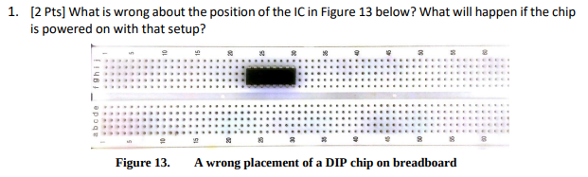

The position of the IC in Figure 13 on the breadboard leads to unintended pin connections due to the columns being connected. To prevent this issue, reposition the IC lower on the board, separating the sets of pins from each other. Powering the chip with the current setup risks multiple power and ground connections, complicating and potentially rendering the circuit unusable.



A NOR gate with interconnected inputs from a single source functions as a NOT gate. NANDs and NORs are preferable as they are less expensive and easier to design, while able to implement other gates such as NOT, AND, and NOR making them versatile and efficient choices in digital circuitry.

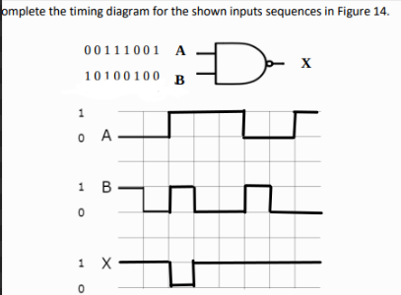

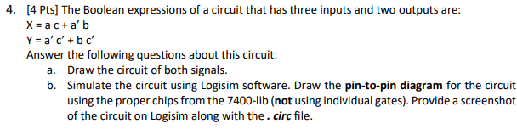

**Circuit Raw Sketch:**

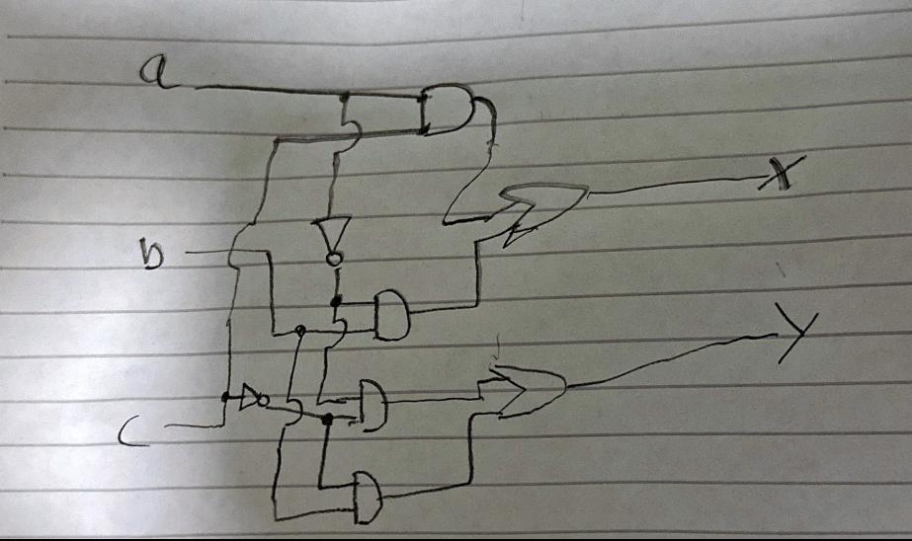

**Circuit Simulation:**

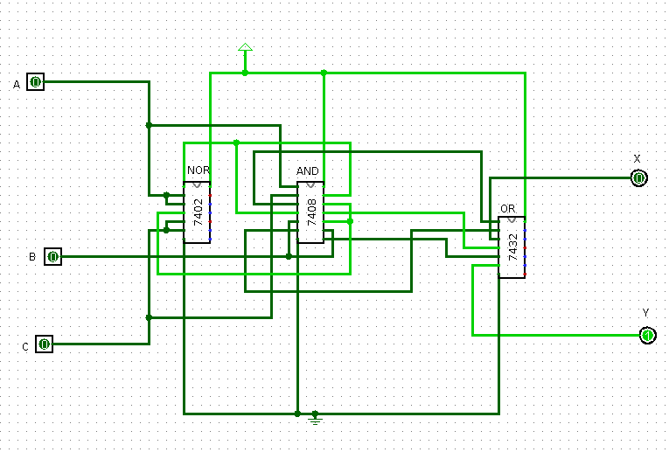

**Circuit Analysis:**

